WEEK-12 –Creating IAM USER with permission Access it with GUI and CLI
Part A: GUI Access (Management Console)
Objective: Create an IAM user with restricted permissions and verify access via the AWS web portal.
1. Administrative Setup (Root User)
- Step 1: Log in to the AWS Management Console as the Root User.
- Step 2: Search for IAM under the "Security, Identity, & Compliance" category.
- Step 3: Navigate to Users and click Create user.
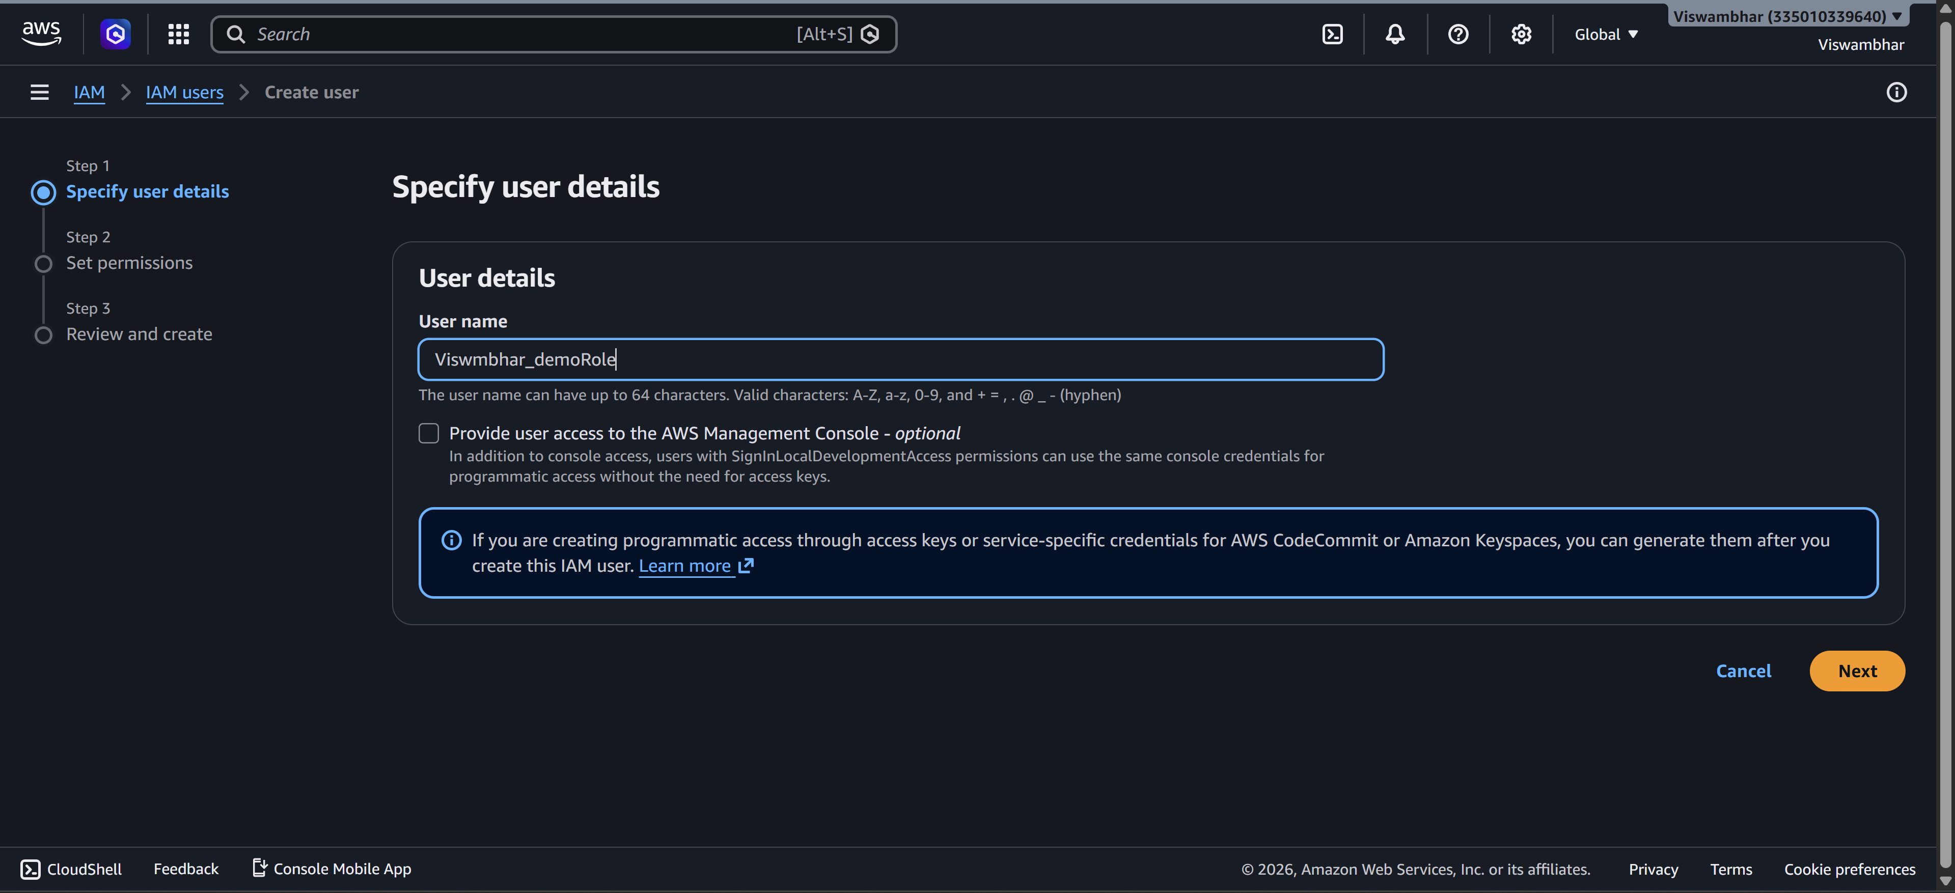
- Step 4: User Details: Enter a name (e.g., S3_Specialist). Check the box for "Provide user access to the AWS Management Console." – custom password.
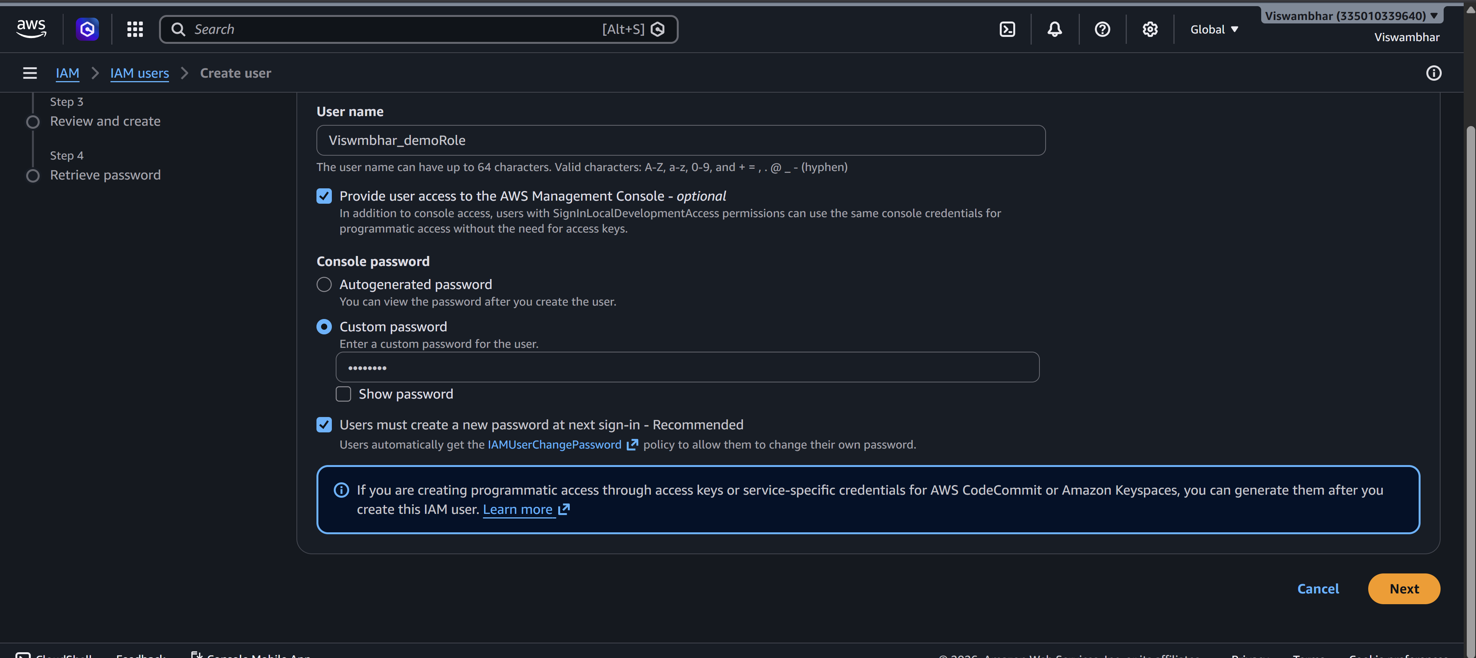
- Step 5: Set Permissions: Select "Attach policies directly." Search for and select AmazonS3FullAccess.
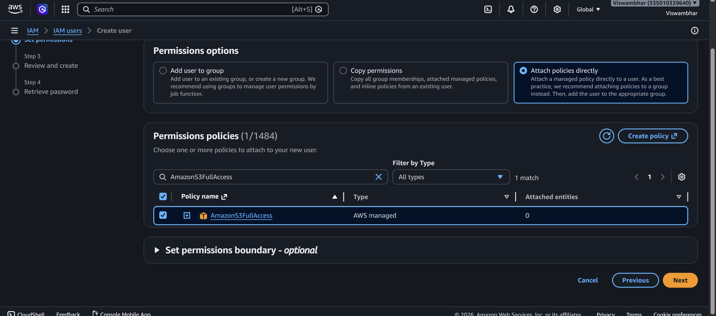
- Step 6: Review & Create: Complete the wizard. On the final page, click Download .csv file.
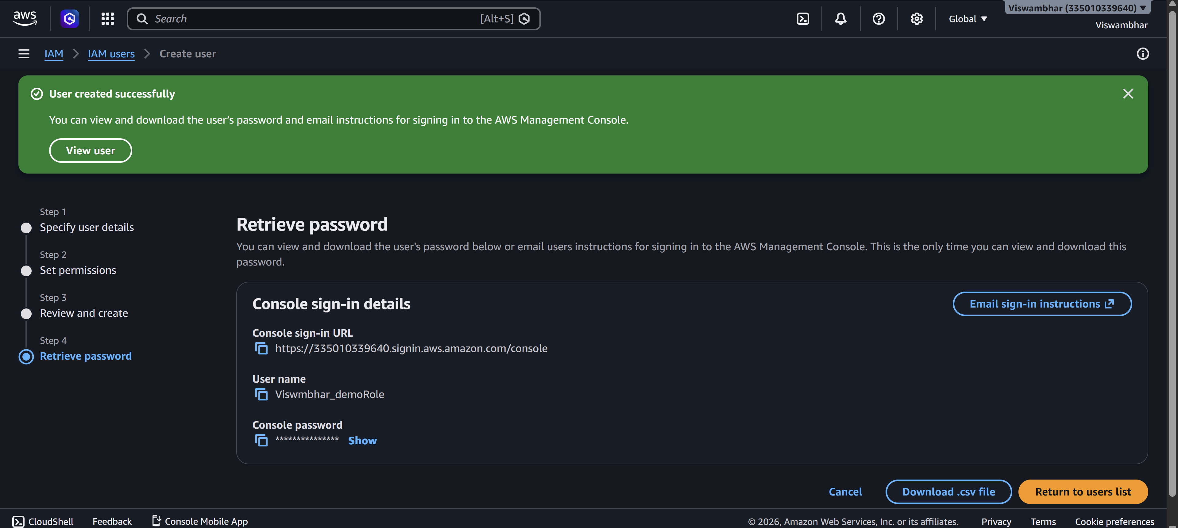
Note: This file contains your Console Password and the unique Sign-in URL.
- Step 7: Copy your 12-digit Account ID (found in the top-right dropdown or the .csv) and Sign Out.
2. Verification (IAM User Login)
- Step 8: Use the Sign-in URL from the .csv (or go to the AWS sign-in page and select IAM User).
- Step 9: Enter the Account ID, then the IAM Username and Password from the .csv.
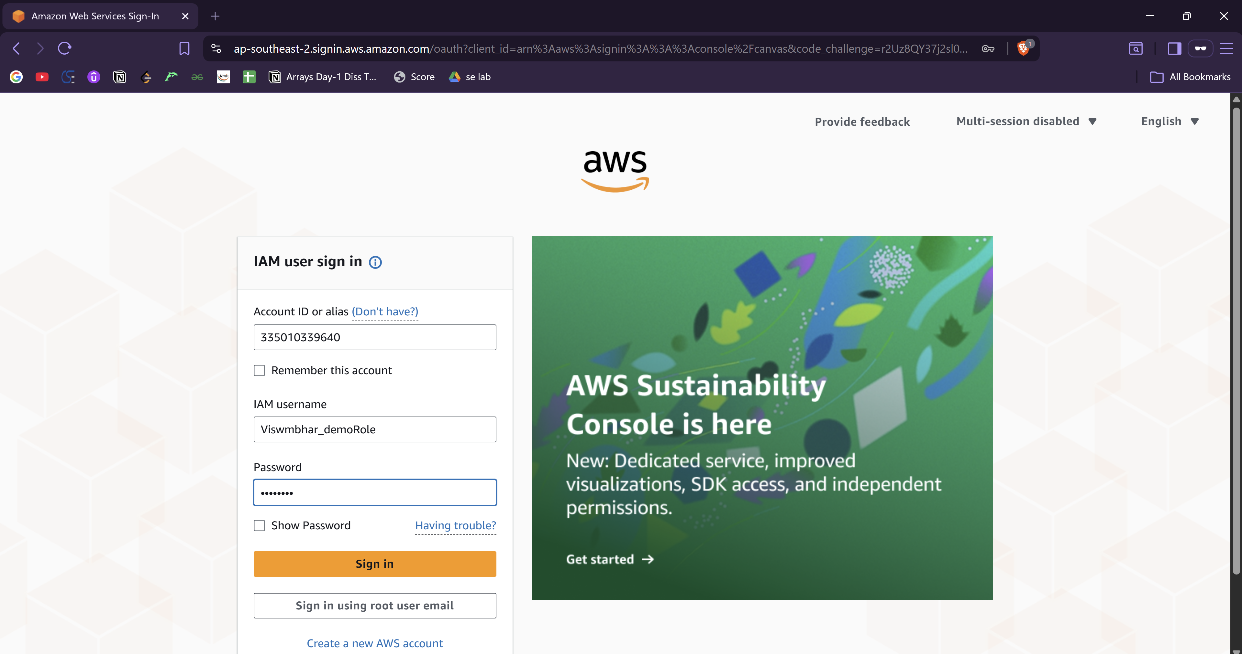
- Step 10: The Logic Test:
  - Test 1 (Failure): Navigate to EC2. Try to view instances. You will see "API Error" or "Access Denied." This proves the user is restricted.
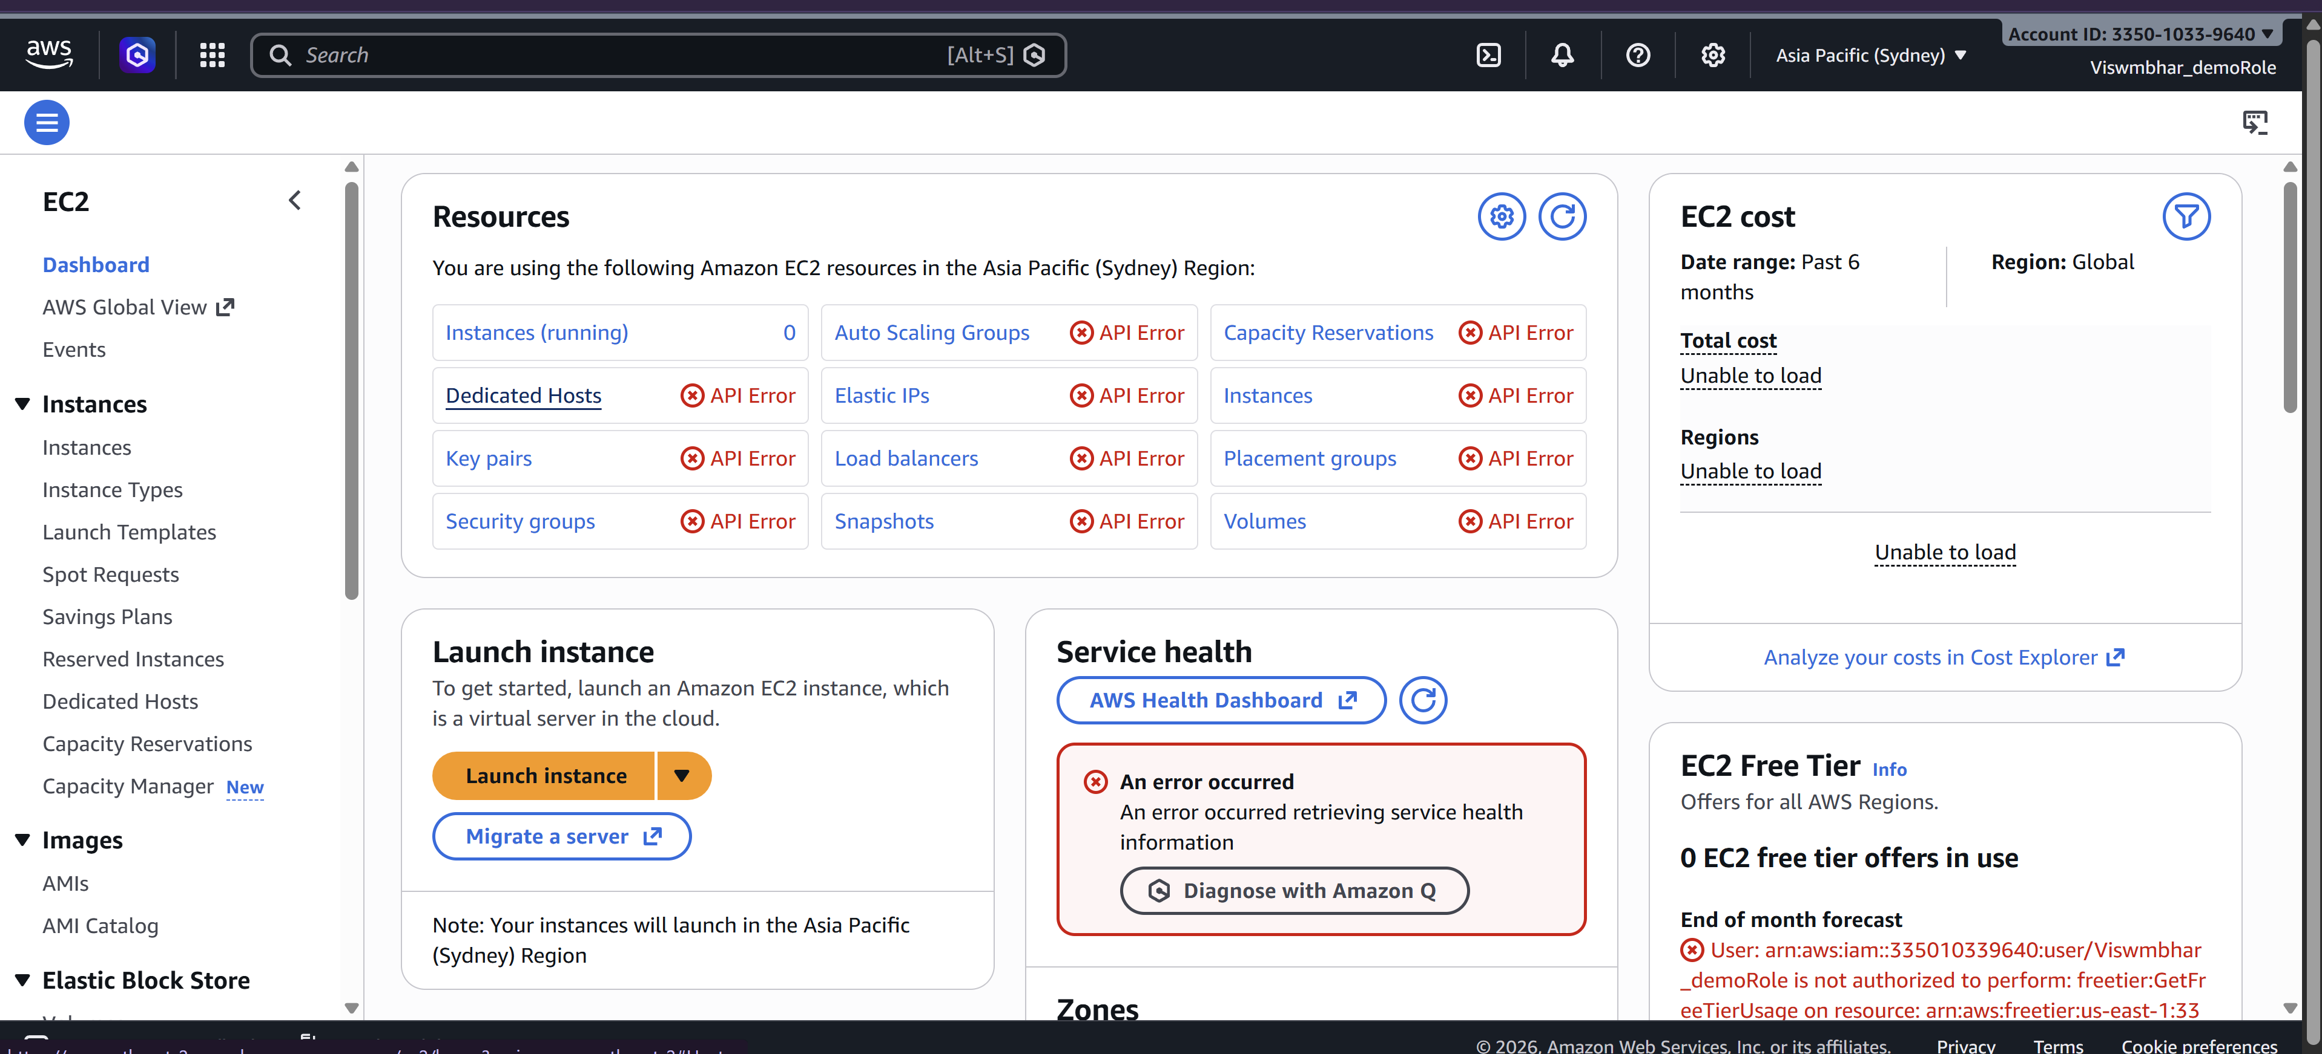
  - Test 2 (Success): Navigate to S3. Create a new bucket. It will work perfectly because of the attached policy.
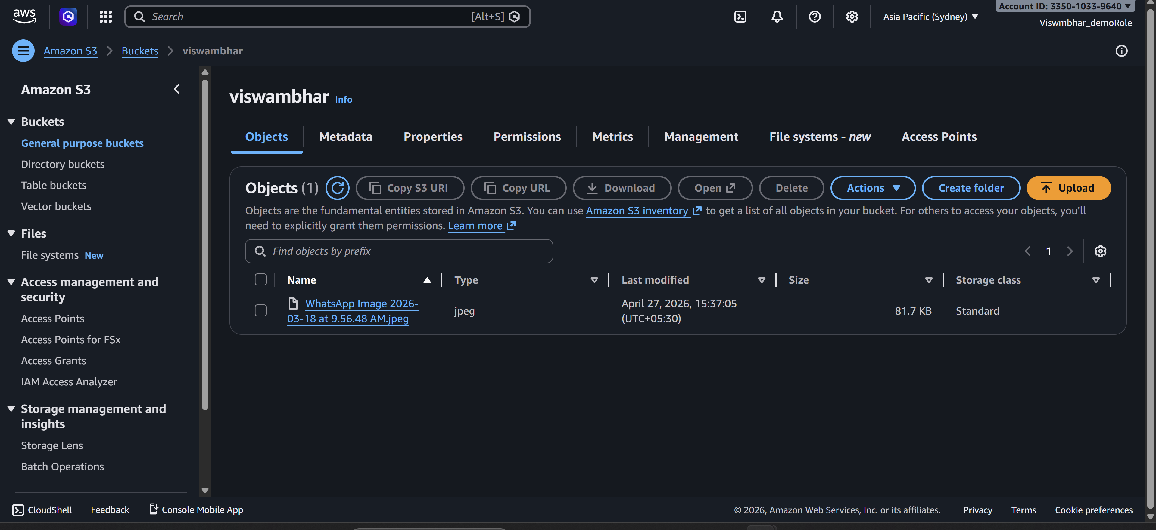

Part B: CLI Access (Programmatic Access)
Objective: Access AWS resources from a standalone system (CMD/Terminal) using security keys.
1. Credential Generation
- Step 1: While logged in as an Admin/Root, go to IAM > Users and click on your user.
- Step 2: Go to the Security credentials tab. Scroll to Access keys and click Create access key.
- Step 3: Select Command Line Interface (CLI). Acknowledge the warning and click Next.
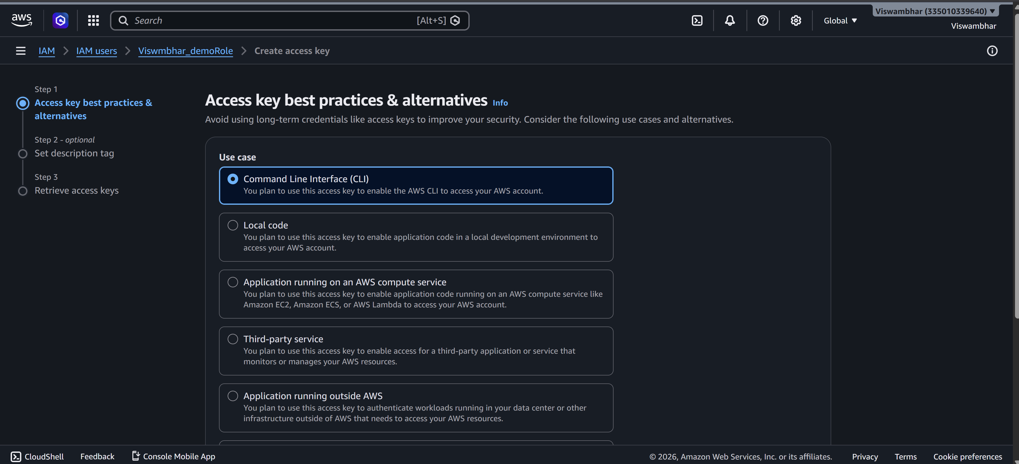
- Step 4: Download the .csv file. > Critical: This contains the Access Key ID and Secret Access Key. If lost, you must delete and recreate them.
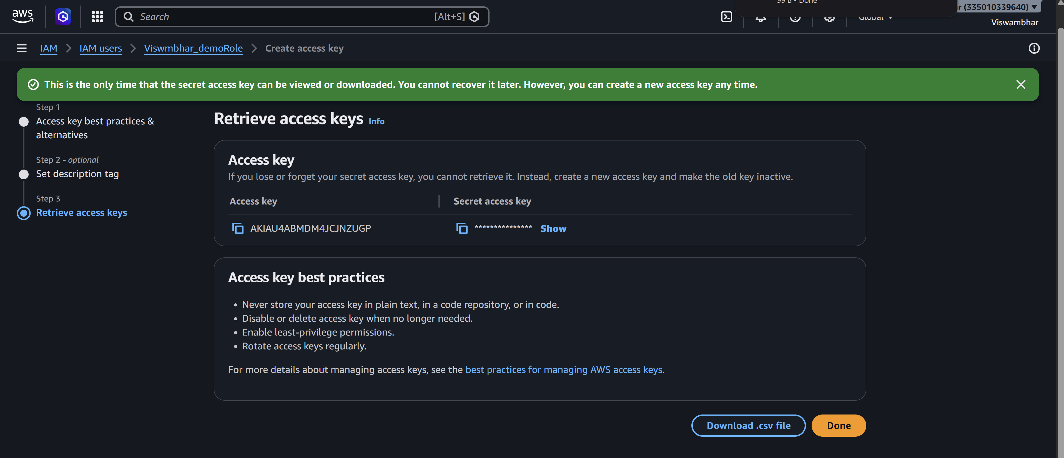
2. Standalone System Configuration
- Step 5: Install the AWS CLI Tool from google on your computer.
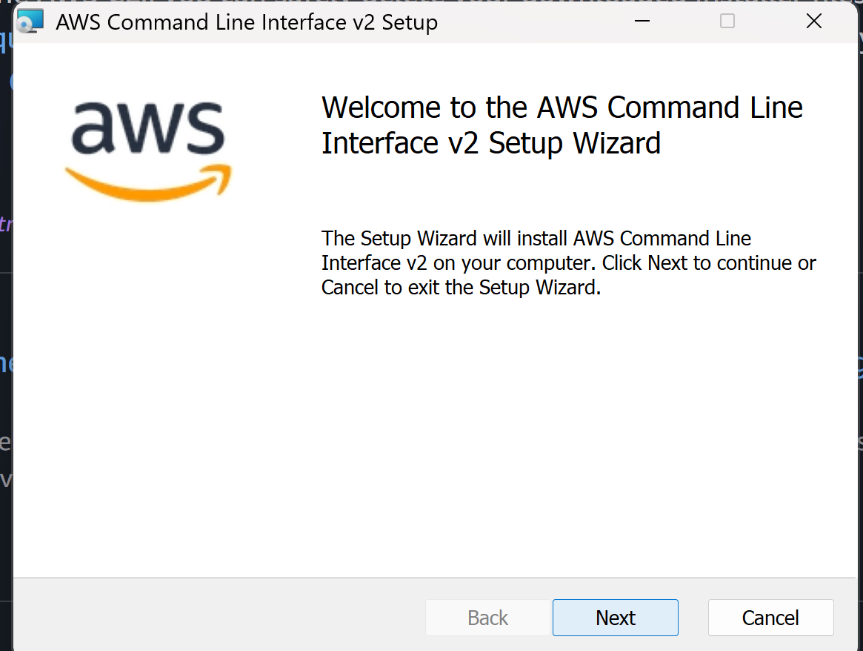
- Step 6: Open your Command Prompt (CMD) or Terminal.
- Step 7: Type aws configure and press Enter.
- Step 8: Provide the following from your .csv:
  - Access Key ID
  - Secret Access Key
  - Default region: (e.g., ap-south-1)
  - Default output: json
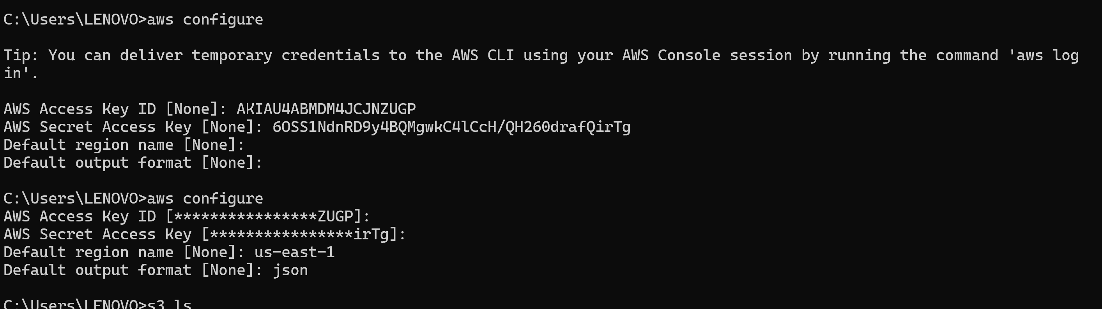
3. Verification via Commands
- Step 9: Run aws s3 ls. This should list your buckets.
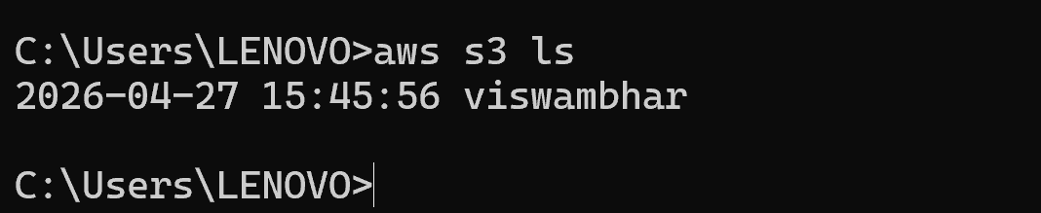
- Step 10: Run aws s3 mb s3://your-unique-bucket-name. (Success)
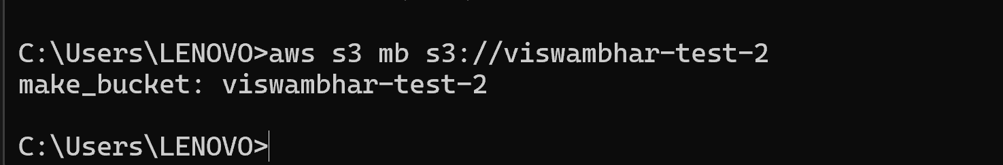
- Step 11: Run aws iam list-users.
  - Result: You will get an (AccessDenied) error.
This confirms that the CLI is respecting the same IAM policy as the GUI.

